**1. Evaluation by Single Bubble:**

To evaluate uncertainty with CA and its alternatives, we have presented 10 examples of circles with different percentages of uncertainty/CA for user perception. Then we have added a questionnaire section with five circles one after another and the task is defined as to determine the uncertainty based on prior perception for each circle and write the corresponding answer in percentage (x%) afterwards.

**1.1 Ca Evaluation section:**

**Examples in % for user perception:**  
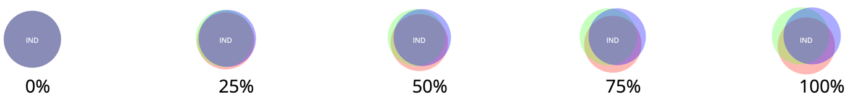

**Questionnaire:**

Q1. Estimate the uncertainty for the following circle in the range 10% to 100%

Answer:

Q2. Estimate the uncertainty for the following circle in the range 10% to 100%

Answer:

Q3. Estimate the uncertainty for the following circle in the range 10% to 100%

Answer:

Q4. Estimate the uncertainty for the following circle in the range 10% to 100%

Answer:

Q5. Estimate the uncertainty for the following circle in the range 10% to 100%

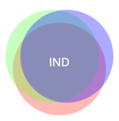

Answer:

**1.2 ca-static Evaluation section:**

**Examples in % for user perception:**

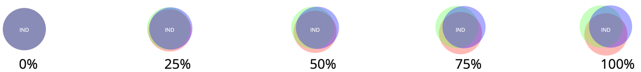

**Questionnaire:**

Q1. Estimate the uncertainty for the following circle in the range 10% to 100%

Answer:

Q2. Estimate the uncertainty for the following circle in the range 10% to 100%

Answer:

Q3. Estimate the uncertainty for the following circle in the range 10% to 100%

Answer:

Q4. Estimate the uncertainty for the following circle in the range 10% to 100%

Answer:

Q5. Estimate the uncertainty for the following circle in the range 10% to 100%

Answer:

**1.3 Blur evaluation section:**

**Examples in % for user perception:**

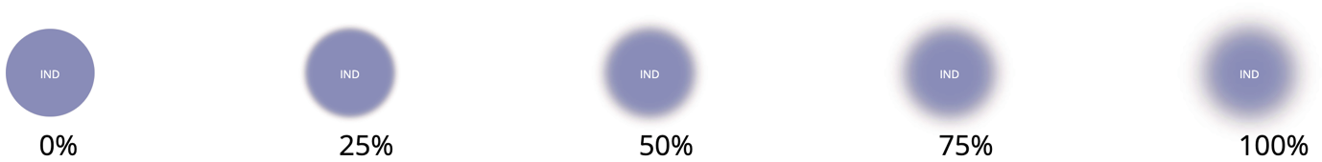

**Questionnaire**:

Q1. Estimate the uncertainty for the following circle in the range 10% to 100%

Answer:

Q2. Estimate the uncertainty for the following circle in the range 10% to 100%

Answer:

Q3. Estimate the uncertainty for the following circle in the range 10% to 100%

Answer:

Q4. Estimate the uncertainty for the following circle in the range 10% to 100%

Answer:

Q5. Estimate the uncertainty for the following circle in the range 10% to 100%

Answer:

**1.4 Noise evaluation section**:

**Examples in % for user perception:**

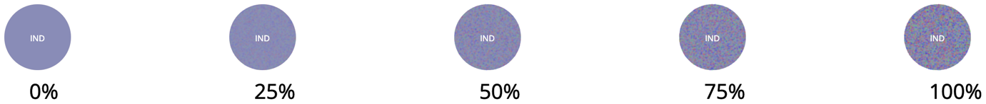

**Questionnaire:**

Q1. Estimate the uncertainty for the following circle in the range 10% to 100%

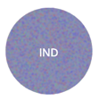

Answer:

Q2. Estimate the uncertainty for the following circle in the range 10% to 100%

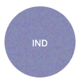

Answer:

Q3. Estimate the uncertainty for the following circle in the range 10% to 100%

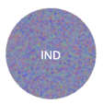

Answer:

Q4. Estimate the uncertainty for the following circle in the range 10% to 100%

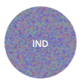

Answer:

Q5. Estimate the uncertainty for the following circle in the range 10% to 100%



Answer:

**2. Bubble Chart with three Countries**

This chart is drawn with three countries only to gradually introduce the difference to the user. Since in previous section there was only one country, there was nothing to compare side by side but here in Figure-3 user can compare both uncertainties.   
**

Figure-3: Bubble chart with three countries

1. United States (USA) shows maximum uncertainty among three.

|  |  |  |  |  |
| --- | --- | --- | --- | --- |
| Strongly  agree | Partially  agree | Neither agree nor disagree | Partially  disagree | Strongly  disagree |

1. Let say, USA has 100% uncertainty, then what will be for Brazil (BRA)?

|  |  |  |  |  |
| --- | --- | --- | --- | --- |
| 20% | 30% | 50% | 60% | 70% |

1. Let say, USA has 100% uncertainty, then what will be for India (IND)?

|  |  |  |  |  |
| --- | --- | --- | --- | --- |
| 30% | 50% | 60% | 70% | 80% |

1. Based on Figure-3 uncertainty is irrelevant to the number of infections.

|  |  |  |  |  |
| --- | --- | --- | --- | --- |
| Strongly  agree | Partially  agree | Neither agree nor disagree | Partially  disagree | Strongly  disagree |

**3. Bubble Chart with Ten Countries**

This is an extended version of Figure-3 where we have used data for 10 countries. All three countries from the earlier Figure-3 are also here but the order of uncertainties has been changed and that is especially noticeable here.

Figure-4: Bubble chart with ten countries

**Questions:**

1. Germany (DEU) shows maximum uncertainty among tens.

|  |  |  |  |  |
| --- | --- | --- | --- | --- |
| Strongly  agree | Partially  agree | Neither agree nor disagree | Partially  disagree | Strongly  disagree |

1. Cuba (CUB) shows minimum uncertainty among tens.

|  |  |  |  |  |
| --- | --- | --- | --- | --- |
| Strongly  agree | Partially  agree | Neither agree nor disagree | Partially  disagree | Strongly  disagree |

1. To determine maximum uncertainty between Argentina (ARG) and Spain (ESP) is ambiguous.

|  |  |  |  |  |
| --- | --- | --- | --- | --- |
| Strongly  agree | Partially  agree | Neither agree nor disagree | Partially  disagree | Strongly  disagree |

1. Still in Figure-4 uncertainty is irrelevant to the number of infections (Circle size) of the countries.

|  |  |  |  |  |
| --- | --- | --- | --- | --- |
| Strongly  agree | Partially  agree | Neither agree nor disagree | Partially  disagree | Strongly  disagree |

**4. Bubble Chart With 50 Countries:**

In this Figure-4, we have utilized data for 50 countries. Since the chart is zoomable, we have not shown label for the smaller circumference countries due to insufficient space to accommodate and can be zoomed-in to see the corresponding label of the country. We are skipping those countries to make any question regarding them.

Figure-4: Bubble chart for 50 countries

**Questions:**

1. United States (USA) shows maximum uncertainty among all countries.

|  |  |  |  |  |
| --- | --- | --- | --- | --- |
| Strongly  agree | Partially  agree | Neither agree nor disagree | Partially  disagree | Strongly  disagree |

1. Quite impossible to determine the minimum uncertainty country.

|  |  |  |  |  |
| --- | --- | --- | --- | --- |
| Strongly  agree | Partially  agree | Neither agree nor disagree | Partially  disagree | Strongly  disagree |

1. Second and third largest uncertainty countries are still confusing.

|  |  |  |  |  |
| --- | --- | --- | --- | --- |
| Strongly  agree | Partially  agree | Neither agree nor disagree | Partially  disagree | Strongly  disagree |

1. Kazakhstan (KAZ) has higher uncertainty than Turkey (TUR)

|  |  |  |  |  |
| --- | --- | --- | --- | --- |
| Strongly  agree | Partially  agree | Neither agree nor disagree | Partially  disagree | Strongly  disagree |

1. Difficult to justify with naked eye if some countries have uncertainties like Israel (ISR).

|  |  |  |  |  |
| --- | --- | --- | --- | --- |
| Strongly  agree | Partially  agree | Neither agree nor disagree | Partially  disagree | Strongly  disagree |

**5. Streamgraph (Single Country-Argentina)**

This stream graph is generated with the predicated data for Argentina. Every dotted column represents an average prediction of ‘Number of cases’ for three consecutive days and based on that they have different uncertainty values in scale range of 0 to 9. Uncertainties are represented here in terms of chromatic aberration of dots (bubbles). Single bubble with higher color intensity column represents lowest uncertainty and three smaller bubbles with lower color intensity column represents higher uncertainty.  **A picture containing background pattern
**

**Figure-5: Texture Streamgraph**

**Questions:**

1. The color intensity of the bullets(dots) is proportional to the chromatic aberration.

|  |  |  |  |  |
| --- | --- | --- | --- | --- |
| Strongly  agree | Partially  agree | Neither agree nor disagree | Partially  disagree | Strongly  disagree |

1. Height of the peaks is irrelevant to the chromatic aberration.

|  |  |  |  |  |
| --- | --- | --- | --- | --- |
| Strongly  agree | Partially  agree | Neither agree nor disagree | Partially  disagree | Strongly  disagree |

1. If first column has aberration=5 and third column=2 then what will be for second column?

|  |  |  |  |  |
| --- | --- | --- | --- | --- |
| 6  7  7  8  9 |  |  |  |  |

1. What is the chromatic aberration(uncertainty) of the highest column?

|  |  |  |  |  |
| --- | --- | --- | --- | --- |
|  | 0  1  2  3  4 |  |  |  |

**6. Texture Streamgraph (Two Countries – India & USA)**

This chart is generated the two countries of India and United States. Columns and structure of bubbles represents the same behavior as that of Figure-5.

**Figure-6: Streamgraph with textures**

**Questions:**

1. The stream flow gives clear indication of both countries.

|  |  |  |  |  |
| --- | --- | --- | --- | --- |
| Strongly  agree | Partially  agree | Neither agree nor disagree | Partially  disagree | Strongly  disagree |

1. Each column represents different amount of chromatic aberration for the countries.

|  |  |  |  |  |
| --- | --- | --- | --- | --- |
| Strongly  agree | Partially  agree | Neither agree nor disagree | Partially  disagree | Strongly  disagree |

1. In the middle part (lower peaks) upper country shows higher aberration and lower country shows higher aberration.

|  |  |  |  |  |
| --- | --- | --- | --- | --- |
| Strongly  agree | Partially  agree | Neither agree nor disagree | Partially  disagree | Strongly  disagree |

1. The height of the peaks is independent on chromatic aberration for both countries.

|  |  |  |  |  |
| --- | --- | --- | --- | --- |
| Strongly  agree | Partially  agree | Neither agree nor disagree | Partially  disagree | Strongly  disagree |

**7. Starfish layout [Maybe we can delete this from survey?]**

This chart drawn over bubble chart where a wing is drawn from the center of the circles and each wing is another stream graph with three model’s predicted data.

**Figure-6: Star-fish layout on bubble chart**

**Questions:**

1. India has smaller stream because pandemic affected later compared to others.

|  |  |  |  |  |
| --- | --- | --- | --- | --- |
| Strongly  agree | Partially  agree | Neither agree nor disagree | Partially  disagree | Strongly  disagree |

1. Some countries have thinner wing due to higher number of counts and uncertainty.

|  |  |  |  |  |
| --- | --- | --- | --- | --- |
| Strongly  agree | Partially  agree | Neither agree nor disagree | Partially  disagree | Strongly  disagree |

1. Smaller circle countries do not have bigger stream wing, so less uncertainty.

|  |  |  |  |  |
| --- | --- | --- | --- | --- |
| Strongly  agree | Partially  agree | Neither agree nor disagree | Partially  disagree | Strongly  disagree |

1. Variation of uncertainty is independent on number of cases(size of circle).

|  |  |  |  |  |
| --- | --- | --- | --- | --- |
| Strongly  agree | Partially  agree | Neither agree nor disagree | Partially  disagree | Strongly  disagree |

**8. Parallel Coordinates**

Parallel plots or parallel coordinates plots allows one to compare the features of several individual observations (series) on a set of numeric variables. Each horizontal axis represents a variable and often has its own scales, and the units can even be different. The dotted lines represent the uncertainty flow whereas the solid lines represent predictions.

Figure-7: Parallel Coordinate Chart for four countries

**Questions:**

1. Australia shows higher uncertainty for “new_tests”

|  |  |  |  |  |
| --- | --- | --- | --- | --- |
| Strongly  agree | Partially  agree | Neither agree nor disagree | Partially  disagree | Strongly  disagree |

1. Brazil shows higher uncertainty for “new deaths”

|  |  |  |  |  |
| --- | --- | --- | --- | --- |
| Strongly  agree | Partially  agree | Neither agree nor disagree | Partially  disagree | Strongly  disagree |

1. Uncertainty for Austria almost remain steady for all properties.

|  |  |  |  |  |
| --- | --- | --- | --- | --- |
| Strongly  agree | Partially  agree | Neither agree nor disagree | Partially  disagree | Strongly  disagree |

**9. Usage Chart**This chart helps us to indicate daily uncertainty presentation in terms of chromatic aberration for every country by date in each cell. The higher uncertainty represents maximum aberration with combination of bright colors in the cells. Given examples of two cells for 92% and 21% chromatic aberration.   
  
Figure-8: Usage Chart (partial chart due to space limitation)

**Questions:**

1. Uncertainties for United Kingdom are not recognizable for every day.

|  |  |  |  |  |
| --- | --- | --- | --- | --- |
| Strongly  agree | Partially  agree | Neither agree nor disagree | Partially  disagree | Strongly  disagree |

1. Uncertainties for United Kingdom are not recognizable for every day.

|  |  |  |  |  |
| --- | --- | --- | --- | --- |
| Strongly  agree | Partially  agree | Neither agree nor disagree | Partially  disagree | Strongly  disagree |

**10. Horizontal Chart**

Horizontal charts are small-multiple area charts that allow greater precision for a given vertical space by using colored bands. Chromatic aberrations are represented by the color variations over the deep purple color for each country from left to right.

Figure-8: Horizontal Chart (partial due to space issue)

**Questions:**

1. Belarus shows maximum chromatic aberration/uncertainty throughout the time.

|  |  |  |  |  |
| --- | --- | --- | --- | --- |
| Strongly  agree | Partially  agree | Neither agree nor disagree | Partially  disagree | Strongly  disagree |

1. Nepal shows lower chromatic aberration in terms of number of counts.

|  |  |  |  |  |
| --- | --- | --- | --- | --- |
| Strongly  agree | Partially  agree | Neither agree nor disagree | Partially  disagree | Strongly  disagree |